Name:_________________________________________________ Date:________________ Period: _______

Circuits – Quiz 3A (10 Points) HONORS Mr. Werman
Complete the circuit breakdown by filling in the blanks below. Be sure to include appropriate units.
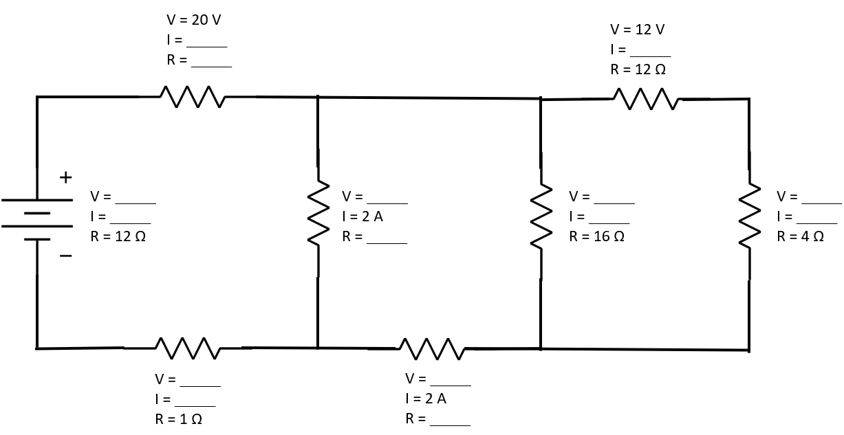

Extra Credit on Back:
Extra Credit (2 Points):
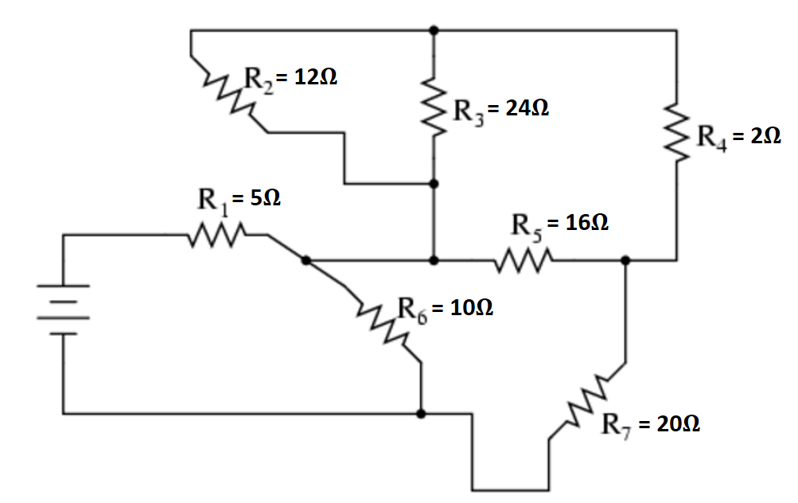
Determine the equivalent resistance (R_{EQ}) of the following circuit.

